Mount Prospect School District 57



Helping
Children
Cope

Tips for Parents

The following information is adapted from the Genesee County Community Mental Health Prevention and Information Services, Flint, Michigan.



General Guidelines


It is beneficial for parents to use challenging situations as times to check-in with their children about their fears and thoughts, and to use the “teachable” moments to help them develop empathy, tolerance, resilience, and acceptance.

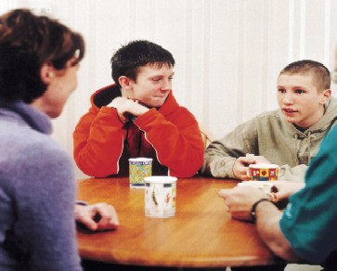
“Helping children cope through grieving and mourning”

The grieving process is not the same for everyone. It is complicated, and differs from person to person. You will not see children moving neatly from one defined stage of grief to another. It is more common for children to drift between the stages of anger, denial and acceptance.
You can help your child through the grieving process by:

- Talking with your child. Provide direct and simple information, but allow time for processing.

- Listen with a neutral perspective as your child shares his or her feelings.
- Reassure your child that it’s okay to feel upset or sad, but that you will be there to help them through.
- Observe your child at play. Listen to what is said and how they play. Frequently children express feelings of fear or anger while playing with toys or friends.
- Allow your child to grieve and mourn. Giving the child the opportunity to express feelings is important to healthy emotional growth.

- Maintain as normal and consistent a routine as possible.

- Focus on positive memories and share stories that celebrate the life of the deceased.

If you feel your child needs additional support please do not hesitate to contact your child’s principal, school social worker, school psychologist or classroom teacher.

Fairview 847-394-7320 Lions Park 847-394-7330
Lincoln 847-394-7350 Westbrook 847-394-7340

